 |  | March 16, 2026

Ivy Tech College School of Information Technology ChatBot Design Document
 | Prepared for: | Prepared by:
 | Ivy Tech College  School of Information Technology  SDEV 265 - Spring 2026  Steve Carver, Ed. D., MS, MS | Green Team:  Gislaine Azevedo  Zachary Thomas  Kirnechla Davis  Kipp Shinabarger

Contents
Contents 2
Document Purpose 3
Introduction 3
System Overview 4
Entity Relationship Diagram (ERD) 5
Chatbot Database Entity Relationship Diagram 6
Sequence Diagrams 7
Chatbot Conversation Processing Flow 8
Architecture Design 8
Presentation Layer 9
Application Layer 9
Data Layer 10
Layered System Architecture 10
Class Diagram 11
Chatbot UML Class Diagram 13
Database Management Strategy 15
Database Design 15
Campus Location Table 15
Intent Table 16
Pattern Table 16
Response Table 17
Language Table 17
Course Prefix Table 18
Interface Design 18
Use Cases 19
Use Case 1 – Retrieve Campus Phone Number 19
Use Case 2 – Request Course Information 19
Use Case 3 – Ask for Help 19
Test Cases 20
Test Case Table 20
Proposed Improvements 22
Updating Third-Party Dependencies 22
Accessibility Improvements to Chatbot User Interface 23
Course Catalog Prefix Recognition and Smart URL Generation 25
Helpful Responses for Unrecognized Queries 26
General Help Command 27
Summary 28

Document Purpose
This design document describes the architecture, structure, and technical components of the Ivy Tech Student Support Chatbot system. The purpose of this document is to provide a clear blueprint of how the chatbot system is designed and how its components interact with each other.
This document includes the system architecture, database structure, UML diagrams, interface design, use cases, and testing approach. By documenting these elements, the development team ensures that the chatbot system is maintainable, scalable, and easier to enhance in future development cycles.

Introduction
This document presents the system design and technical architecture for the Ivy Tech Student Support Chatbot. The purpose of this design document is to describe how the chatbot system will be structured, how its components interact, and how data will be stored and retrieved during system operation.
The design phase of a software development project is an important step that bridges the gap between requirements analysis and implementation. During this phase, the development team defines the system architecture, identifies the required data structures, and plans how the different components of the application will interact with one another.
The Ivy Tech Student Support Chatbot is a web-based application designed to assist students by providing quick access to commonly requested institutional information such as campus contact details, course catalog resources, student services, and academic support information. Students interact with the chatbot through a conversational interface where they type questions and receive automated responses generated by the system.
The system runs within a web browser environment such as Google Chrome, Microsoft Edge, or Safari. The application logic is implemented using JavaScript and Node.js, while chatbot knowledge is stored in a structured relational database containing intents, response messages, language support, campus information, and course prefixes.
The goal of this design document is to provide a clear technical blueprint for the chatbot system so that developers can understand how the application components operate together and how the system can be improved and expanded in future development phases.

System Overview
The Ivy Tech Student Support Chatbot is intended to provide students with quick access to institutional information without requiring direct human assistance. Many students have common questions regarding campus phone numbers, course information, student services, and institutional resources. The chatbot acts as a virtual assistant that can answer these questions instantly.
The system works by analyzing user messages and matching them with predefined patterns stored in the chatbot database. Each pattern corresponds to an intent that represents the meaning of the user’s question. Once the chatbot identifies the intent, it retrieves the appropriate response from the database and returns it to the user.
The chatbot system also supports multiple languages and can be expanded to support additional languages in the future. This allows the chatbot to serve a diverse student population. The database structure includes tables that store campus locations, course prefixes, chatbot intents, response messages, and language support.
The improved version of the chatbot includes several enhancements such as improved error handling, additional chatbot intents, accessibility improvements, and better database organization.

Entity Relationship Diagram (ERD)
The Entity Relationship Diagram (ERD) illustrates how the chatbot database tables interact with each other. The database structure organizes chatbot knowledge into multiple relational tables that store intents, responses, patterns, campus information, and language support.
The Intent table defines the type of request the chatbot can recognize. Each intent represents a specific type of user question such as requesting campus contact information or course details.
The Pattern table stores example phrases that users may type when asking a question. These patterns are used by the chatbot’s pattern matching system to detect the user’s intent. Each pattern is linked to a specific response through the response identifier.
The Response table stores the chatbot replies that are returned to the user. Each response is associated with an intent and may include additional information such as URLs or resource links.
The Language table allows the chatbot to support multiple languages. This enables the system to provide responses based on the user’s selected language.
The CampusLocation table stores information about Ivy Tech campuses, including addresses, phone numbers, and contact information. This allows the chatbot to provide campus-specific information when requested.
The CoursePrefix table stores academic course prefixes such as SDEV, DBMS, and CSCI, allowing the chatbot to recognize course-related questions and direct students to the appropriate catalog resources.
This relational structure allows the chatbot to efficiently identify user intents, retrieve relevant responses, and provide accurate information to students.

Chatbot Database Entity Relationship Diagram
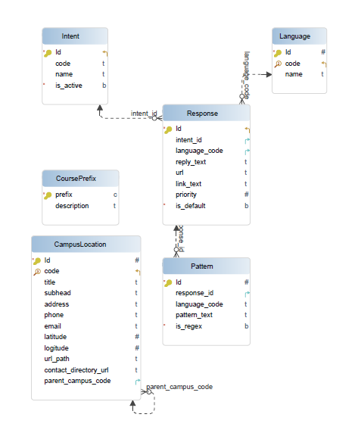

The ERD demonstrates a modular database structure where the Intent table acts as the central entity, connecting user input patterns with stored responses. This design allows the chatbot system to scale easily by adding new patterns and responses without modifying the core application logic.

Sequence Diagrams
Sequence diagrams illustrate how system components interact over time when a user communicates with the chatbot.
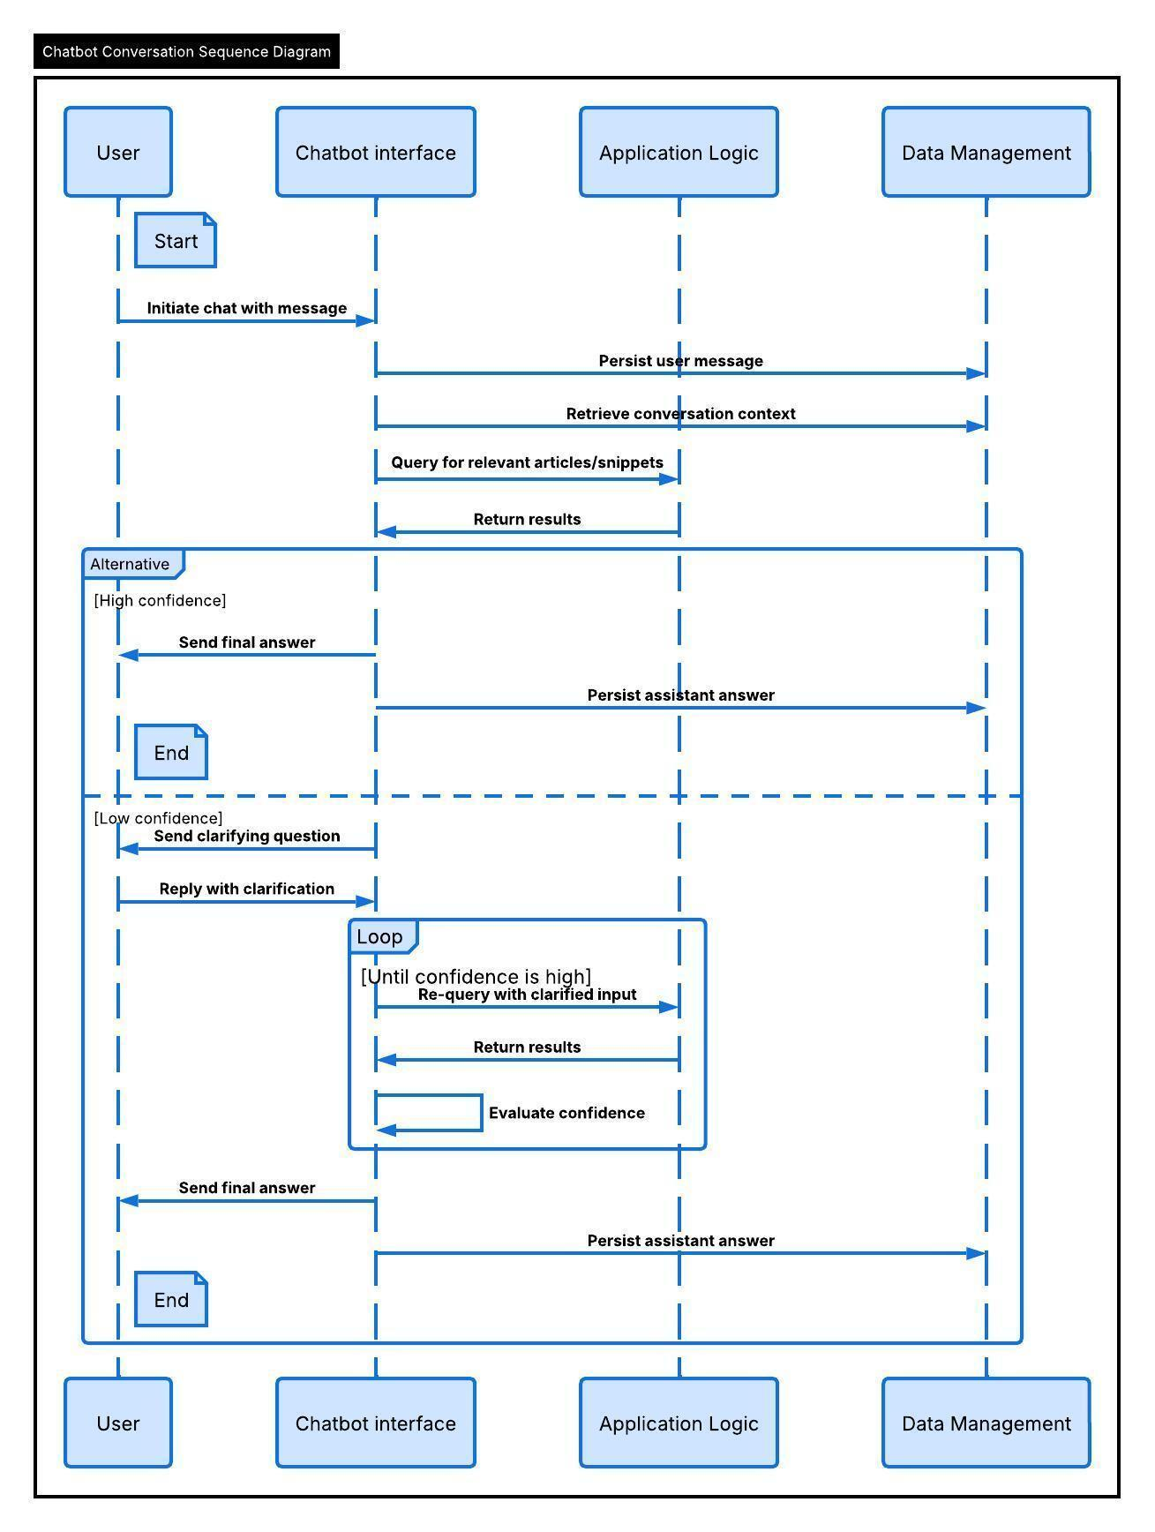

Chatbot Conversation Processing Flow
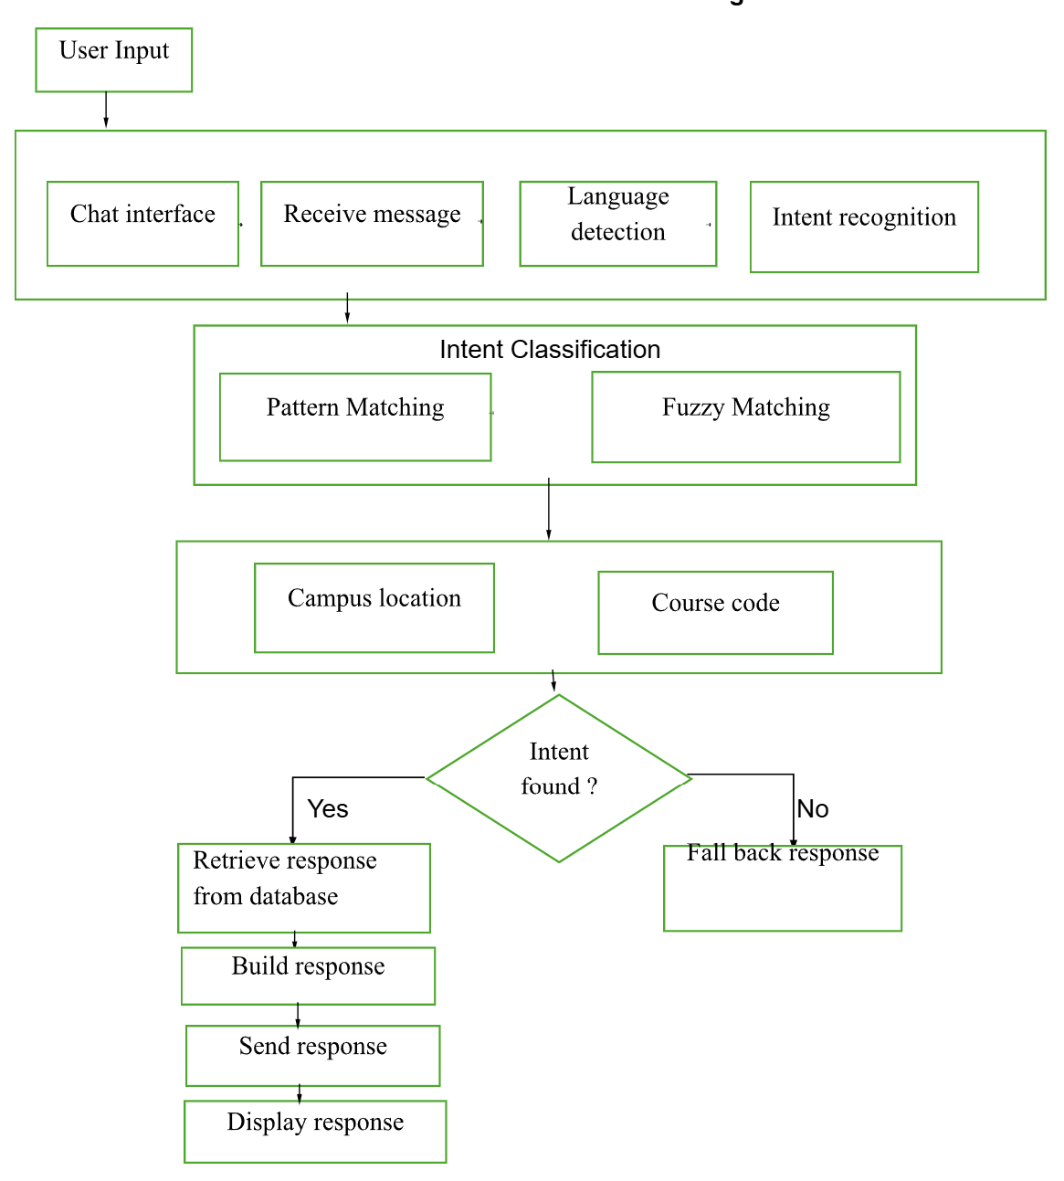
The conversation processing flow diagram illustrates how the chatbot processes user messages and generates responses. When a user submits a message through the chatbot interface, the system receives the input and begins processing the request.

Architecture Design
The Ivy Tech Student Support Chatbot follows a layered system architecture that separates the application into multiple logical layers. This architectural approach improves system maintainability, scalability, and modularity by ensuring that each layer has a clearly defined responsibility.
By separating the user interface, application logic, and data storage into independent layers, developers can modify or enhance individual components without affecting the rest of the system. This design also supports future expansion of the chatbot system and allows additional features to be implemented more easily.

Presentation Layer
The presentation layer contains the user interface of the chatbot. This layer is responsible for displaying the chat window, receiving user input, and displaying chatbot responses.
Components include:
- chat interface
- message display window
- input text field
- send button

Application Layer
The application layer contains the logic responsible for processing user input and determining the correct response. This layer analyzes user messages, identifies intents, and retrieves information from the database.
Components include:
- intent recognition
- conversation management
- response selection logic
- error handling

Data Layer
The data layer contains the database that stores chatbot data such as patterns, intents, responses, and campus information.
Components include:
- relational database tables
- query processing
- data storage and retrieval
Separating the system into layers ensures that the user interface, application logic, and database remain independent from one another.

Layered System Architecture

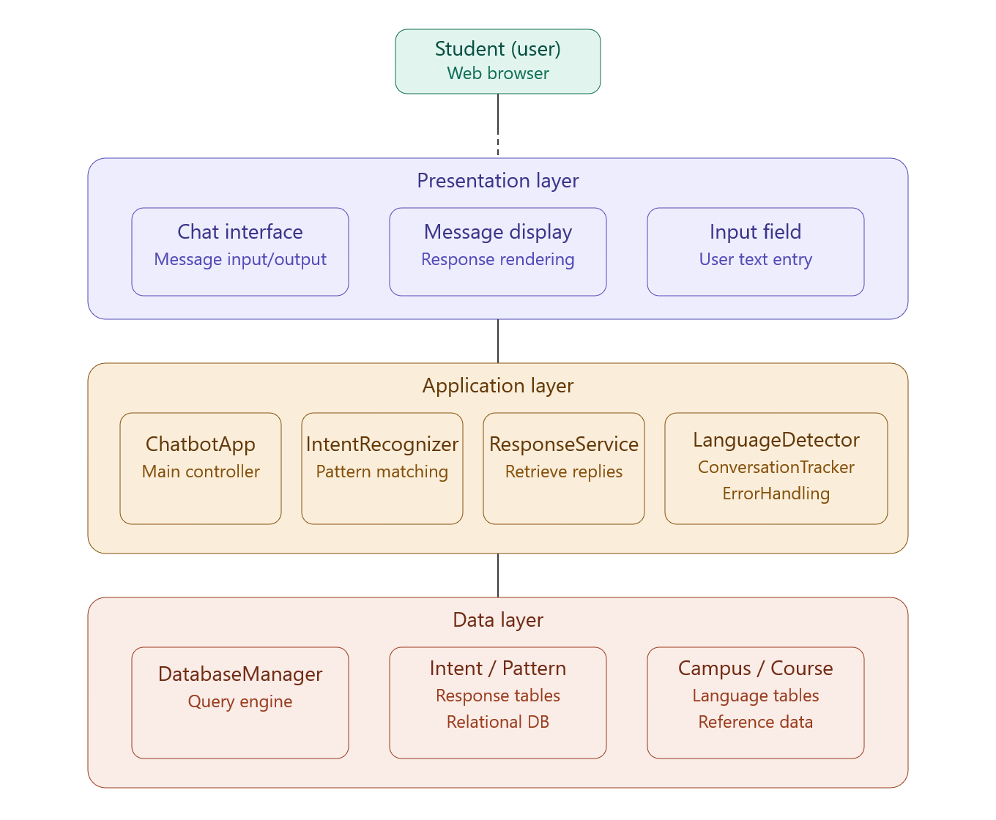

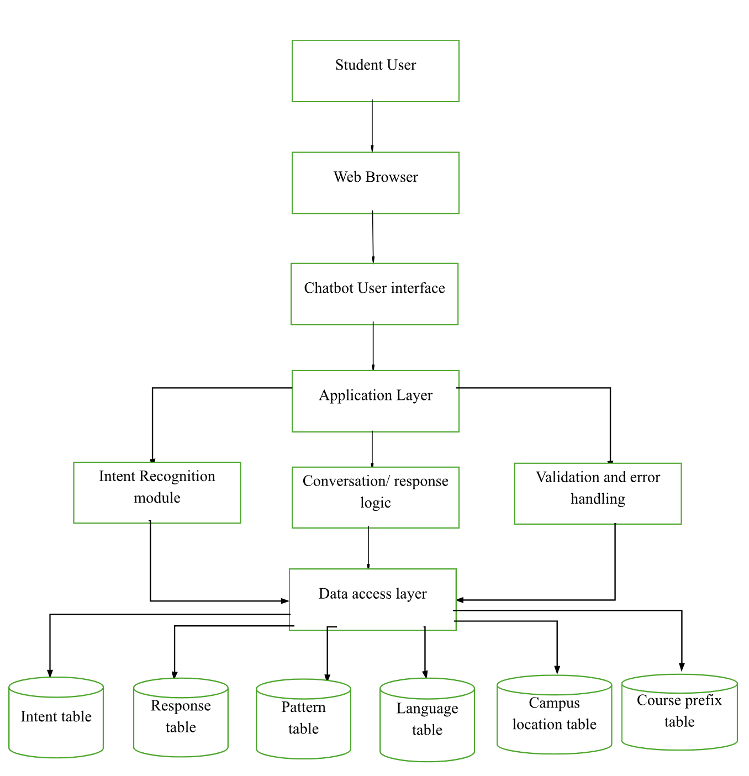

Class Diagram
The class diagram represents the structural design of the chatbot system and illustrates how the main software components interact with one another. The chatbot system follows a modular architecture where responsibilities are separated between processing logic, data management, and response generation.
The ChatbotApp class serves as the main controller of the chatbot system. It manages the communication between the user interface and the backend processing components. The ChatbotApp receives user messages, sends them to the intent recognition system, and returns the generated responses to the user interface.
The IntentRecognizer class is responsible for analyzing the user’s message and determining the most appropriate intent. This component evaluates predefined patterns and uses fuzzy string matching techniques to detect the intent that best represents the user’s request.
The ResponseService class generates the chatbot response after the intent has been identified. It retrieves response templates from the database and formats the output that will be sent to the user. This service is also responsible for generating dynamic responses such as course catalog links or campus information.
The LanguageDetector class determines the language used in the user's message. This allows the chatbot to support multilingual responses by selecting the appropriate language version of the response.
The ConversationTracker class maintains conversation history and stores interactions between the user and the chatbot. This allows the system to preserve context between messages and log interactions for analysis and improvement of chatbot responses.
The DatabaseManager class manages communication between the application and the chatbot database. It retrieves data related to intents, patterns, responses, campus locations, course prefixes, and supported languages.
The Intent class represents the meaning behind a user request. Each intent contains multiple patterns and is associated with one or more responses.
The Pattern class stores the phrases or expressions used to match user input with a specific intent.
The Response class stores the chatbot replies that will be returned to the user. Responses may contain additional elements such as hyperlinks or external resource references.
The CampusLocation class stores information about Ivy Tech campuses, including campus names, addresses, phone numbers, and email contact information.
The Language class allows the chatbot system to support multiple languages by storing language identifiers and language names.
The CoursePrefix class stores course subject prefixes used for recognizing course-related questions and generating course catalog links.
Together, these classes define the internal structure of the chatbot system and demonstrate how user input is processed, interpreted, and converted into useful responses.

Chatbot UML Class Diagram
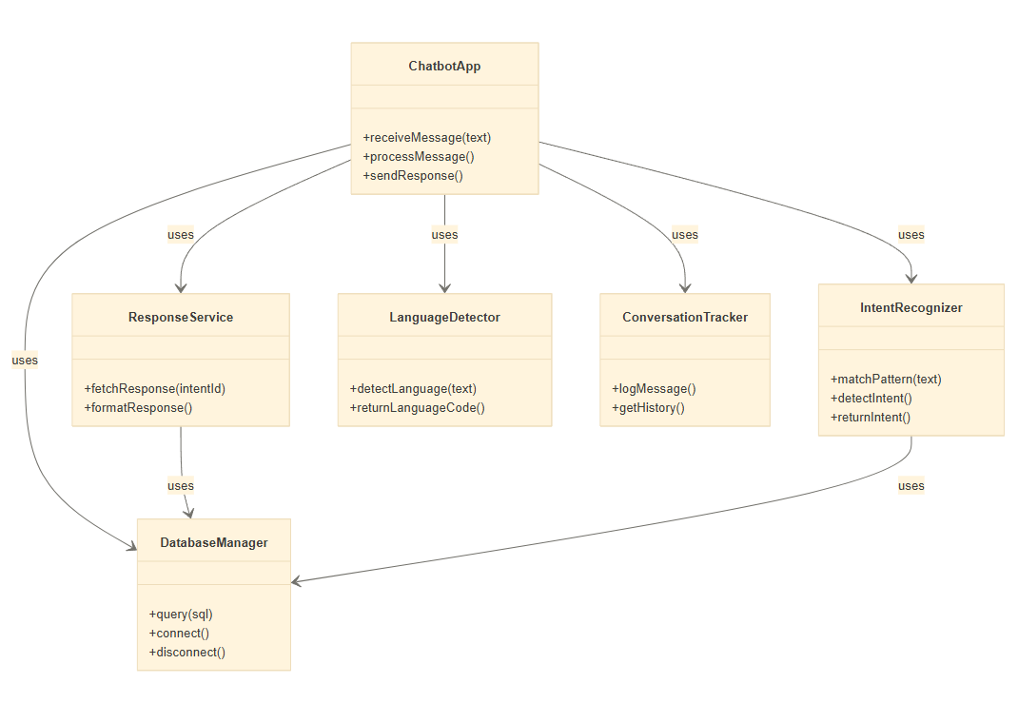
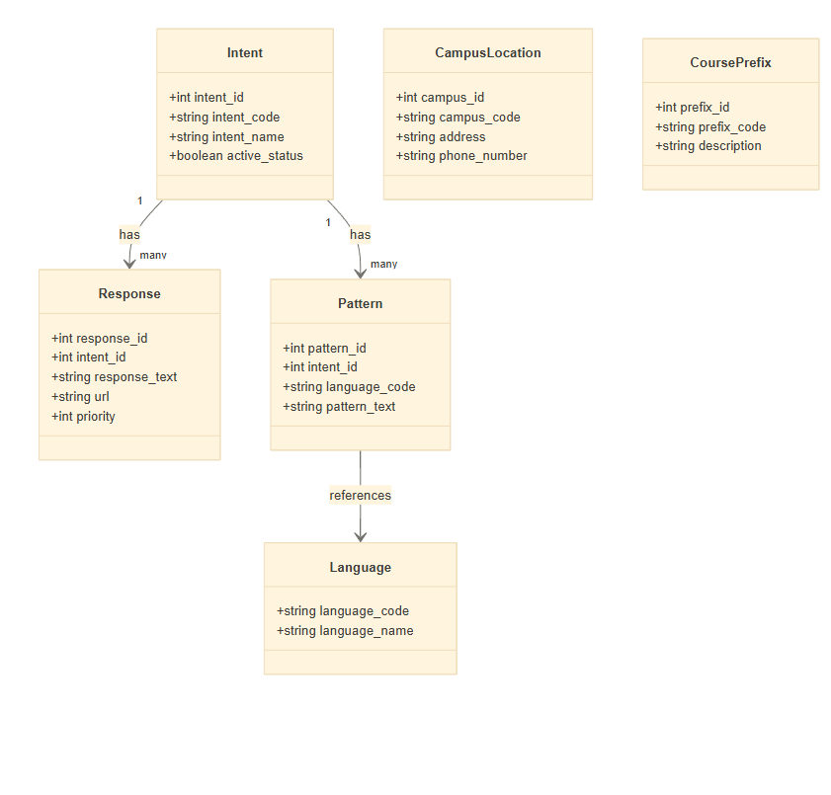

Database Management Strategy
The chatbot system relies on a structured relational database to manage the information required to respond to user requests. The database organizes chatbot knowledge into multiple related tables that store intents, patterns, responses, campus information, course prefixes, and supported languages.
By organizing chatbot data into normalized relational tables, the system can efficiently search for patterns, identify intents, and retrieve appropriate responses. This database structure also allows new chatbot knowledge to be added easily without modifying the core chatbot application logic.

Database Design
The chatbot system relies heavily on a structured relational database to store information required for responding to user requests.

Campus Location Table
This table stores information about each Ivy Tech campus including address and contact information.
Field Name | Data Type | Key | Description
campus_id | INTEGER | Primary Key | Unique identifier for each campus location
campus_code | VARCHAR(10) | Unique | Short code used to identify the campus
campus_title | VARCHAR(100) |  | Official name of the Ivy Tech campus
address | VARCHAR(255) |  | Physical address of the campus location
phone_number | VARCHAR(20) |  | Main contact phone number for the campus
email | VARCHAR(100) |  | Official contact email for the campus
website_url | VARCHAR(255) |  | Link to the campus website page
The CampusLocation table allows the chatbot system to retrieve campus-specific information when students request contact details such as phone numbers, addresses, or campus websites.

Intent Table
The Intent table defines the types of questions the chatbot system can recognize. Each intent represents the meaning behind a user request.
Field Name | Data Type | Key | Description
intent_id | INTEGER | Primary Key | Unique identifier for intent
intent_code | VARCHAR | Unique | Short code representation intent
intent_name | VARCHAR |  | Name of intent
active_status | BOOLEAN |  | Indicates if intent is active
The Intent table serves as the central component of the chatbot knowledge base. Each intent represents a specific type of user request and links user input patterns to the responses stored in the database.

Pattern Table
The Pattern table stores example phrases that users may type when interacting with the chatbot. These patterns help the chatbot recognize user intents
Field Name | Data Type | Key | Description
pattern_id | INTEGER | Primary Key | Unique identifier for each pattern
response_id | INTEGER | Foreign key | References the response associated with the pattern
language_code | VARCHAR(10) | Foreign key | Identifies the language used for the pattern
pattern_text | TEXT |  | Example user phrase used to detect the intent
regex_indicator | BOOLEAN |  | Indicates whether the pattern uses regex matching

The Pattern table contains example phrases used to match user input with the correct intent. Pattern matching techniques such as fuzzy matching or regular expressions are used to detect similarities between user messages and stored patterns.

Response Table
The Response table stores the chatbot replies that are returned to users after an intent is detected.
Field Name | Data Type | Key | Description
response_id | INTEGER | Primary key | Unique identifier for each response
intent_id | INTEGER | Foreign key | References the intent associated with the response
response_text | TEXT |  | Text message returned by the chatbot
url | VARCHAR(255) |  | Optional link to additional resources
link_text | VARCHAR(100) |  | Display text for the associated link
default_response | BOOLEAN |  | Indicates if the response is the default fallback
The Response table stores the chatbot’s reply messages that are delivered to users after an intent is identified. Some responses may include additional links directing students to official Ivy Tech resources

Language Table
The Language table allows the chatbot system to support multiple languages
Field Name | Data Type | Key | Description
language_code | VARCHAR(10) | Primary key | Unique code representing the language
language_name | VARCHAR(50) |  | Name of the supported language
.The Language table allows the chatbot system to support multilingual responses by storing language identifiers that correspond to supported languages within the chatbot system

Course Prefix Table
The CoursePrefix table stores academic course prefixes used by Ivy Tech.
Field Name | Data Type | Key | Description
prefix_code | VARCHAR(10) | Primary key | Unique course subject prefix
prefix_title | VARCHAR(100) |  | Full name of the academic subject
catalog_url | VARCHAR(255) |  | Link to the course catalog page

The CoursePrefix table allows the chatbot to recognize course-related questions and generate links to the Ivy Tech course catalog for specific subject areas.

Interface Design
The user interface of the chatbot is designed to be simple, accessible, and easy to use for students. The chatbot appears as a chat window embedded within a webpage where users can type questions and receive responses instantly.
The interface includes a message display area where conversation history is shown and a text input field where users type their questions. When the user presses the send button, the message is transmitted to the chatbot engine for processing.
Accessibility improvements are an important aspect of the updated design. Previous versions of the chatbot used light colored hyperlinks that did not meet accessibility standards for visual contrast. The updated design introduces improved color contrast and readability to comply with accessibility guidelines.
Another interface improvement includes displaying the names of development teams that contributed to the chatbot project when users hover over the copyright section. This feature recognizes previous teams that participated in the development process.

Use Cases
Use cases describe how users interact with the chatbot system to accomplish specific tasks.

Use Case 1 – Retrieve Campus Phone Number
Actor: Student
Goal: Obtain campus contact phone number
Steps:
- Student opens chatbot interface.
- Student asks for campus phone number.
- Chatbot requests campus selection if not already known.
- Student provides campus name.
- Chatbot retrieves phone number from database.
- Chatbot displays phone number.

Use Case 2 – Request Course Information
Actor: Student
Goal: Learn about a specific course
Steps:
- Student asks about a course.
- Chatbot identifies course related intent.
- Chatbot retrieves course prefix or description.
- Chatbot displays course information.

Use Case 3 – Ask for Help
Actor: Student
Goal: Understand chatbot capabilities
Steps:
- Student types "help".
- Chatbot recognizes help intent.
- Chatbot displays list of available commands and information categories.

Test Cases
Test cases are used to verify that the chatbot system processes user input correctly and produces the expected responses. The testing process evaluates the chatbot’s ability to recognize intents, detect language, retrieve relevant information from the database, and handle invalid or unknown user inputs.
Each test case includes the user input, the system operation being tested, and the expected output generated by the chatbot.

Test Case Table
Testing was designed based on the chatbot’s core processing workflow, including intent detection, pattern matching, entity extraction, and response generation.
Test Case ID | Test Scenario | User Input | System Function Tested | Expected Results
TC01 | Greeting detection | “Hello” | Intent detection | Chatbot returns greeting message
TC02 | Greeting fuzzy match | “Hey there” | Fuzzy pattern matching | Chatbot returns greeting response
TC03 | Phone number request | “What is the phone number for Indianapolis campus?” | Location detection + phone response | Chatbot returns Indianapolis campus phone number
TC04 | Address request | “Where is the Bloomington campus”? | Location detection | Chatbot returns Bloomington campus address and map link
TC05 | Course information request | “Tell me about SDEVE 265” | Course prefix validation | Chatbot returns catalog link with warning message
TC06 | Unknown course prefix | “Tell me about ABCD 123” | Course prefix validation | Chatbot returns catalog link with warning message
TC07 | Language detection | Filipino input | Language detection function | Chatbot responds in Filipino
TC08 | Help/information request | “What programs does Ivy Tech offer?” | Intent matching | Chatbot returns programs information link
TC09 | Invalid input | “asdfghjkl” | Error handling | Chatbot returns fallback response
TC10 | Campus dean information | “Who is the dean at Indianapolis campus?” | Intent detection + location lookup | Chatbot returns dean search link
TC11 | Student services question | “What student services are available?” | Intent detection | Chatbot returns student services page
TC12 | Unrecognized query logging | Unknown question | Error response detection | Question is logged in unanswered_inquiries.json
The chatbot system performs both positive testing and negative testing. Positive tests verify that the chatbot correctly identifies user intents and returns the expected responses. Negative tests evaluate how the chatbot handles unknown or invalid inputs.
When the chatbot cannot identify a matching intent, the system generates a fallback response and records the user query in the unanswered_inquiries.json file. This allows developers to review unanswered questions and improve the chatbot knowledge base in future development iterations.
Testing also verifies the system's ability to detect language, recognize course codes, and identify campus locations using pattern matching and fuzzy string comparison algorithms.

Proposed Improvements
During the design analysis phase, several improvements were identified to enhance the performance, usability, and long-term maintainability of the Ivy Tech Student Support Chatbot. These improvements focus on reducing technical debt, improving accessibility compliance, and adding additional features that enhance the user experience while preserving the overall chatbot architecture.
Each proposed improvement has been evaluated based on its impact on the system and the level of effort required for implementation.

Updating Third-Party Dependencies
Objective
The objective of this improvement is to update all third-party packages and dependencies used in the chatbot system to their latest stable versions. Updating these packages helps eliminate known security vulnerabilities, improves application performance, and ensures compatibility with modern development tools.
Current System Condition
The original chatbot was developed using several external libraries and frameworks. Many of these packages have received updates since the chatbot was first developed, including security patches and feature enhancements.
Proposed Implementation
The development team will review all project dependencies and update outdated packages using dependency management tools.
Steps include:
- Running dependency audits using tools such as npm audit or pip list outdated
- Identifying outdated libraries used in the chatbot project
- Updating the following categories of dependencies:
  - Core chatbot framework or bot engine
  - Natural language processing or intent recognition tools
  - User interface components
  - Logging utilities
  - Monitoring tools
  - Analytics libraries
The updated package versions will be recorded in the package.json configuration file and corresponding lock files to ensure consistent builds across development environments.
Expected Benefits
- Improved application security by resolving known vulnerabilities (CVEs)
- Better performance due optimized libraries
- Improved system stability
- Easier integration of future features and enhancement

Accessibility Improvements to Chatbot User Interface
Objective
This improvement focuses on updating the chatbot user interface to comply with WCAG 2.2 AA accessibility standards, ensuring the system is usable by individuals with visual, motor, or cognitive disabilities.
Current System Condition
The original chatbot interface contains visual design elements that do not fully meet accessibility guidelines. For example, some hyperlinks and text colors use light color schemes that do not provide sufficient contrast for users with visual impairments.
Proposed Implementation
The interface will be redesigned to include the following accessibility improvements:
- Increase the contrast ratio between text and background colors to meet the recommended 4.5:1 contrast ratio standard
- Add ARIA attributes to important user interface components to improve screen reader compatibility
- Implement keyboard navigation support so users can interact with the chatbot without a mouse
- Improve keyboard focus indicators to clearly show which element is currently selected
- Provide support for text resizing without breaking the layout
- Reduce or disable unnecessary motion effects to support users with motion sensitivity
- Improve font readability and spacing by updating font stack and line height
Accessibility testing will be performed using both automated and manual tools:
- Automated accessibility scanning tools such as axe and WAVE
- Manual testing with screen reader software
Expected Benefits
- Compliance with university accessibility policies
- Compliance with legal accessibility standards
- Improved usability for users with disabilities
- Better overall user experience for all users

Course Catalog Prefix Recognition and Smart URL Generation
Objective
This feature improves the chatbot’s ability to assist students searching for course information by automatically recognizing course prefixes and generating direct links to the Ivy Tech course catalog.
Current System Condition
Students frequently ask questions about courses using prefixes such as:
- SDEV
- DBMS
- CSCI
- INFM
- MATH
The chatbot currently provides limited support for automatically directing users to catalog search pages.
Proposed Implementation
The chatbot's intent recognition system will be enhanced to detect course prefixes and optional course numbers within user queries.
Examples of supported queries:
- “Show me SDEV classes”
- “Tell me about SDEV 265”
- “Where can I find DBMS courses?”
Implementation steps include:
- Extending the pattern recognition system using regex pattern matching
- Detecting course prefixes and numbers in user messages
- Mapping the recognized prefix to the official Ivy Tech Course Catalog search URL
- Dynamically generating a search link containing the detected course prefix or number
- Returning the generated link in the chatbot response
Example Response
User:
“Show me SDEV 265”
Chatbot:
“You can view the course details here:
“[Course Catalog Search Link]”
Expected Benefits
- Faster navigation to course information
- Improved chatbot usefulness for academic questions
- Increased task completion rate for course-related inquiries

Helpful Responses for Unrecognized Queries
Objective
Improve the chatbot’s behavior when it cannot confidently match a user question by providing helpful suggestions instead of generic error messages.
Current System Condition
When the chatbot cannot identify an intent, it returns a simple fallback response that does not guide the user toward successful interaction.
Proposed Implementation
When a user query cannot be matched to a known intent, the chatbot will:
- Detect that the message is unrecognized
- Provide 2–3 example questions that the chatbot can answer
- Tailor suggestions based on the current conversation context when possible
- Log unrecognized queries for later analysis and training improvements
Example response:
“I’m not sure I understood that question. Here are some things I can help with:
- Find course information (example: Show me SDEV 265)
- Find campus phone numbers (example: What is the Indianapolis campus phone number?)
- Learn about student services
Try asking one of these or type help to see more options.”
Expected Benefits
- Improved user experience
- Reduced user frustration
- Better guidance for new users
- Data collection for future chatbot training improvements

General Help Command
Objective
Provide users with an easy way to learn what the chatbot can do by typing simple commands such as “help”, “what can you do”, or “how does this work.”
Proposed Implementation
A new chatbot intent will be created to detect help-related queries. When triggered, the chatbot will return a structured list of example capabilities.
Example help response:
“I can help with many topics! Here are some examples of what I can do:
Search the Course Catalog
- Example: Show me MATH 220
- Find campus contact information
- Example: What is the Indianapolis campus phone number?
- Locate campus buildings and services
Just type one of these questions or tell me what you need!”
The help response will reuse the same suggestion logic implemented for unrecognized queries to maintain consistent chatbot responses.
Expected Benefits
- Helps new users quickly understand the chatbot capabilities
- Reduces confusion during first-time use
- Improves engagement with the chatbot system

Summary
This design document provides a detailed description of the architecture and internal structure of the Ivy Tech Student Support Chatbot system. The document outlines the system architecture, database design, UML diagrams, interface design, use cases, and testing strategy required to implement the chatbot application.
The chatbot provides an efficient and automated way for Ivy Tech students to obtain important information regarding campus services, academic programs, and institutional resources. By using structured database tables and intent recognition techniques, the chatbot can analyze user questions and provide relevant responses quickly and accurately.
The improvements proposed in this document focus on enhancing the usability, accessibility, and long-term maintainability of the chatbot system. Through careful system design and structured documentation, the development team ensures that the chatbot system can continue to evolve and support Ivy Tech students effectively in future development phases.

